TrailheaDx - Computer Setup – Bootcamp/Trailhead Workshops

# Computer Hardware

Ensure there is a label on the laptop screen with a number on it. (001 – 100) * Each room should begin with 001 through however many computers are in the room.

Please confirm that the TrailheaDX Background Image is on all the computers.

# Shortcuts

Verify that these shortcuts are on the desktop:

|  |  |
| --- | --- |
| * Google Chrome | * Data Loader |
| * Mozilla Firefox | * Notepad++ |

# Bookmarks

1. Open two browsers Google Chrome, Mozilla Firefox, and verify that the home page is [www.salesforce.com](http://www.salesforce.com)

2. Verify that the sites below are **bookmarked** and that they launch successfully:

|  |  |  |
| --- | --- | --- |
| Google  Chrome | Mozilla  Firefox | Link / URL |
| Salesforce login | Salesforce login | <https://login.salesforce.com/> |
| Session Survey | Session Survey | <https://trailhead.getfeedback.com/r/2A5pEzDU/> |
| TrailheaDX | TrailheaDX | <https://developer.salesforce.com/trailheadx> |
| Salesforce  Certification |  | <https://www.webassessor.com/salesforce> |
| Mimeo Ebook | Mimeo Ebook | [https://salesforce.mimeo.digital/](https://t.yesware.com/tt/2f0e3321852c45edd504cdd4618e527b282bd71a/dbc68cb1c74c04e2fedde2c4d7437d3e/8d537a697b1f9b0f165a392189aa7566/salesforce.mimeo.digital/#/login) |

Please Verify the following Applications are installed on the computer.

# Applications

## Data Loader

. Double-click on the **Data Loader** icon on the desktop.

. Verify that the program launches.

. Close the application.

## Notepad ++

. Double-click on the **Notepad++** icon on the desktop.

. Verify that the program launches.

. Close the application.

Please verify the **Chrome Extension** is enabled on CHROME only (in upper right hand corner of browser)



*if extension is missing please add here: <https://chrome.google.com/webstore/detail/tab-resize-split-screen-l/bkpenclhmiealbebdopglffmfdiilejc>

Please check the bookmark is there for [**https://kahoot.it/**](https://www.google.com/url?q=https://kahoot.it/&sa=D&source=hangouts&ust=1520612372860000&usg=AFQjCNGjvFgzL91ASLobZNGhnBtbVu-7sA) **(*Only in Marriot Room Pacific A)**

For the **EMERGING TECH TRACK ONLY (INTERCON ROOM UNION SQUARE)** Please Confirm the following Program/Installs

**Google Chrome (latest)**

* <https://www.google.com/chrome/browser/desktop/index.html>

**Salesforce CLI (latest)**

* <https://developer.salesforce.com/docs/atlas.en-us.sfdx_setup.meta/sfdx_setup/sfdx_setup_install_cli_windows.htm>
* From a Command Prompt enter the following: sfdx update

You should then see the below message

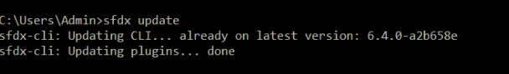

**Git (latest)**

**to check that it is installed on each machine:** run the Windows installer.

* Go to the windows icon (lower left corner) click on search and type in “command prompt” this will bring up a black window.
* type: git --version (make sure you have a space after git)
* If Git is installed, you should get its version:



**Java Standard Edition (SE) Development Kit (JDK) 8u162**

* <http://www.oracle.com/technetwork/java/javase/downloads/jdk8-downloads-2133151.html>

*go to command prompt and type in java -version

Below is the screenshot you should see if installed correctly.

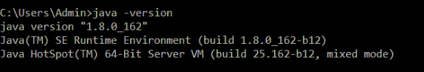

**Visual Studio Code (latest)**

* <https://code.visualstudio.com/>

(go to command prompt and type in code

You should then get a pop up and see the below window

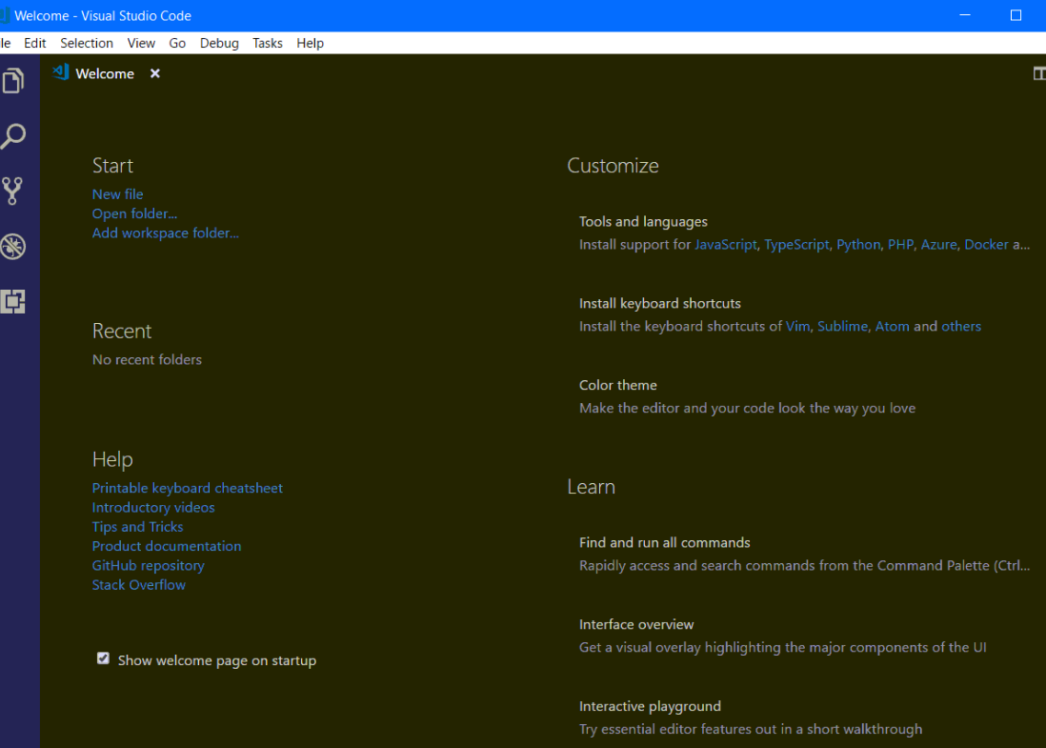

**Salesforce DX Extensions for Visual Studio Code (latest)**

* <https://marketplace.visualstudio.com/items?itemName=salesforce.salesforcedx-vscode>

*to check this is installed go to command prompt and type in code:

Click on the box

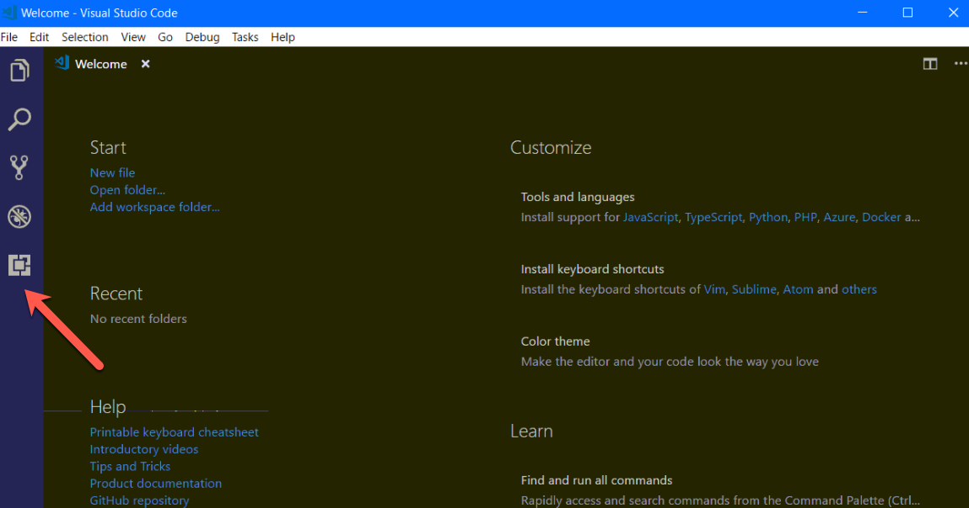

From there click on the 3 dots (arrow pointing at area) and select “show extensions”

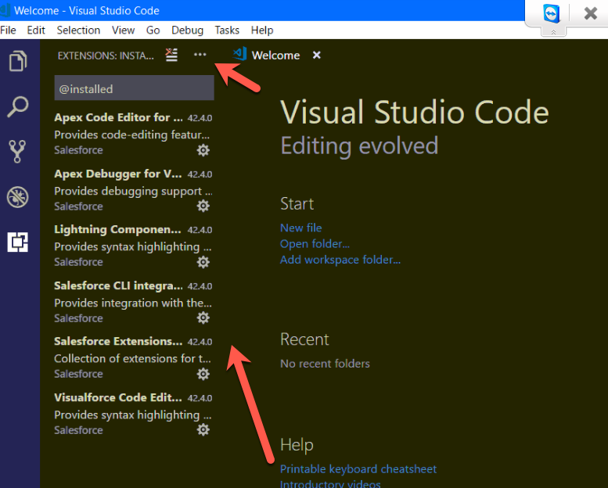

*confirm all 6 programs above are installed.

**Ruby 2.4.x (As of Jan 26 2018, Ruby 2.5.x installer is discouraged by RubyInstaller.org)**

<https://rubyinstaller.org/downloads/>

* 32-bit: <https://github.com/oneclick/rubyinstaller2/releases/download/rubyinstaller-2.4.3-1/rubyinstaller-2.4.3-1-x86.exe>
* 64-bit: <https://github.com/oneclick/rubyinstaller2/releases/download/rubyinstaller-2.4.3-1/rubyinstaller-2.4.3-1-x64.exe>

(Review by going to command prompt and type in ruby –version

*you should then see the screen below if installed.

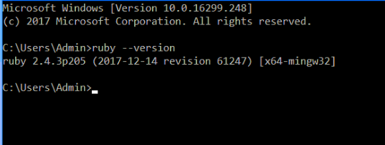

**Travis CI**

* <https://github.com/travis-ci/travis.rb#installation>

(to review this is installed do the following, go to

“Command Prompt” and type in travis version (below is the image you should see if installed)

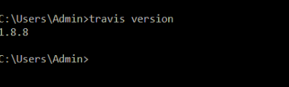

**7-Zip (latest)**

<http://www.7-zip.org/> (go to windows icon and find 7 zip file)

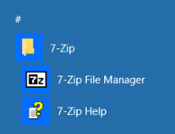

IF THERE IS ANYTHING MISSING PLEASE PUT THE LID OF THE COMPUTER DOWN AND PUT A STICKY NOTE ON THE TOP OF THE LAPTOP VERIFYING WHAT IS MISSING.